Po Leung Kuk Lo Kit Sing (1983) College
Discipline Department
D42
Provisional Class Uniform Design for Endorsement

Class :__________________ Period: - (Year)
(For F.4-F.6, the design can be used for more than one year. e.g. Class: 4A Period: 2013-2015)

Class Uniform Design:
Front
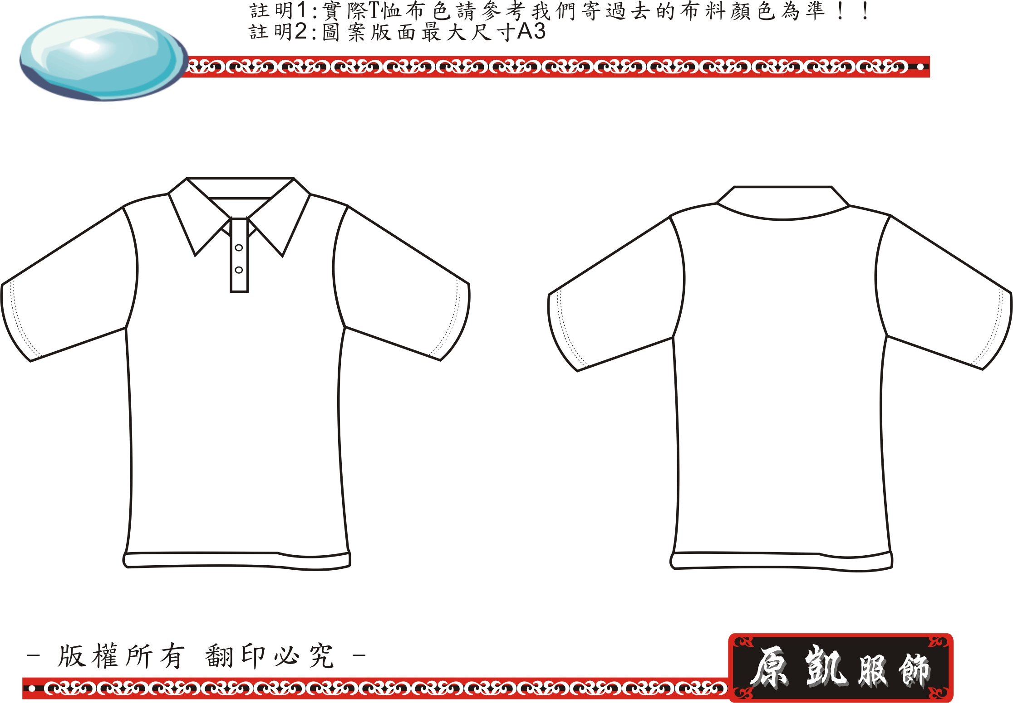
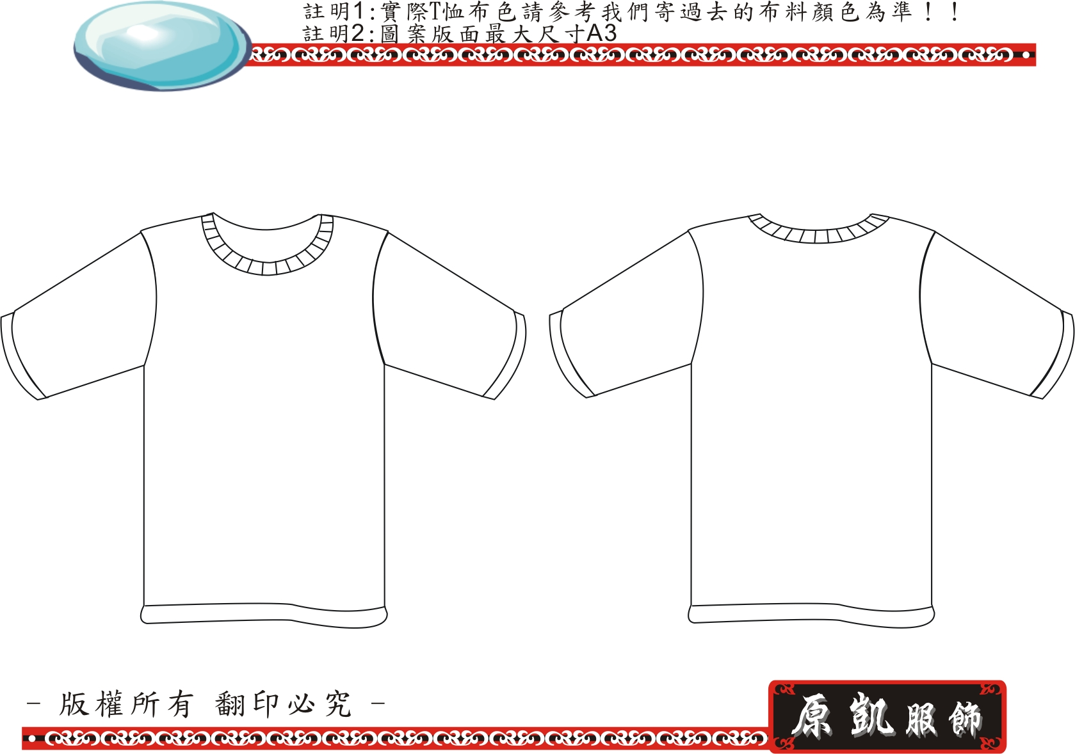
Back
Remarks: 1. Please attach sheet(s) if more space is required.
2. The color design should be submitted with “PLK83” logo.

State the design concept / idea of the Class Uniform:

Teacher-in-charge / Form teacher:
Signature of teacher-in-charge :_____________________ Date : ___________________
Recommendation from Discipline Master:
 1. Approved
 2. Not Approved
 3.Other____________________________________________________________
Signature: ________________________________ Date : ___________________

Principal’s remarks:
 1. Approved
 2. Not Approved
 3. Pending
 4. Others ________________________________________________________________________________________
_________________________________________________________________________________________________________
Signature: _____________________________ Date ______________________

